# Driving Right (2) in Python

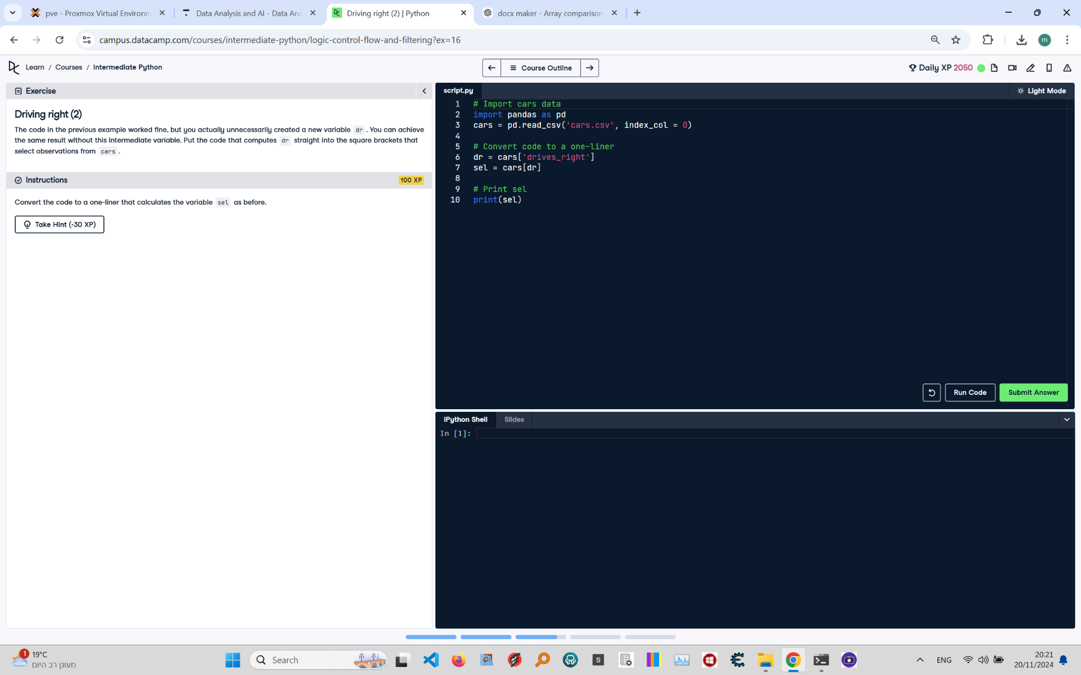

**Question:**

The code in the previous example worked fine, but you actually unnecessarily created a new variable `dr`. You can achieve the same result without this intermediate variable.  
Convert the code to a one-liner that calculates the variable `sel` as before.

**Answer:**

Here is the Python code that solves the problem:

# Import cars data  
import pandas as pd  
  
# Read the dataset  
cars = pd.read_csv('cars.csv', index_col=0)  
  
# One-liner to calculate sel  
sel = cars[cars['drives_right']]  
  
# Print sel  
print(sel)

**Explanation:**

1. **Import Pandas**: The Pandas library is imported to handle tabular data in a DataFrame.  
2. **Read the dataset**: The `pd.read_csv()` function reads the dataset from a CSV file into a Pandas DataFrame. The `index_col=0` parameter sets the first column as the index.  
3. **One-liner to calculate `sel`**: Instead of creating a separate variable for the boolean Series, the code directly uses `cars['drives_right']` inside the brackets to filter the rows where `drives_right` is `True`. The result is stored in `sel`.  
4. **Print the result**: The `print(sel)` statement displays the subsetted DataFrame.